Special Sessions

Recordando al Colegio Jacinto Treviño
Friday, February 29, 2008, 3:00PM
Cafeteria, Building H
The National Association for Chicana and Chicano Studies Tejas Foco and South Texas College would like to dedicate the 2008 Tejas Regional Conference in it’s entirety to the founders, organizers, and students of Colegio Jacinto Treviño for their outstanding efforts to challenge discrimination and provide an avenue of education for Mexican Americans across the Valley. Please join us in a special roundtable discussion composed of the Colegio’s original founders, with a special presentation by Mr. Vicente Carranza

Participating founders include: Narciso L. Alemán, Francisco Briones, Vicente Carranza, Lupe Casares, Martha Cotera, Juan Cotera, Amancio Chapa Jr., Andre Guerrero, Sylvia Llanes, Esmeralda “Lali” Moheno, Víctor Moheno, Aurelio Montemayor, Samuel Nieto, Connie Sánchez, and Rubén Solís

With His Pistol in His Hand: Fifty Years Later
Friday, February 29, 2008, 10:30AM
Building J 1-216
The year 2008 marks the fiftieth anniversary of the publication of With His Pistol in His Hand: A Border Ballad and its Hero by the esteemed Américo Paredes, a native of the Lower Rio Grande Valley or the “Lower Border” as he often called it. The book continues to be arguably the most important single scholarly text in Mexican-American Studies. Jose E. Limon, a student of Américo Paredes in the 1970s, will offer a commentary on the significance of With His Pistol in His Hand at the time of its publication and over the last fifty years.

TEK-iando por la Raza: Group discussion about Latina/o and Native American inclusion within the Texas Essential Knowledge and Skills
Friday, February 29, 2008, 10:30AM
Building J 1-404
Moderators: Mary Helen Berlanga, Texas State Board of Education and Trinidad Gonzales, South Texas College

The purpose of the this group discussion is to explore options on how to include Latina/o and Native American history to the Texas’ core public school curriculum. Currently the TEKS is being revised. This discussion group is an effort to bring together scholars, public officials, K-12 educators and others interested in changing TEKS so that it no longer leaves silent Latina/o and Native American histories. (Supplemented by Friday’s 9:00AM panel: “Challenging the Standards for Teaching History”)

Defend the Honor: When does a Blind Spot Equal Racism?
Saturday, March 1, 2008, 10:30AM
Building J 1-216
In this roundtable, members of the Defend the Honor campaign, led by Dr. Maggie Rivas-Rodríguez, will discuss the 2007 Ken Burns/PBS controversy, in which a 14.5-hour documentary on WWII originally had no Latinos.

Border Studies Club’s Valley Cultural Festival
Friday, February 29th, 2008. All day event on STC Court Yard outside cafeteria area
In conjunction with the NACCS Tejas Regional Conference the Mid-Valley Border Studies Club at South Texas College will be showcasing the many regional influences that make our Rio Grande Valley border region unique.
Scheduled to perform are:
- South Texas Indian Dancers
- Native American groups will demonstrate cultural and traditional artifacts
- 19th Century Tejano and Vaquero demonstrations and performances
- Pan de Campo demonstration and sampling

Joined at the River: The "War on Terror" in Big Bend, Texas
Saturday March 1, 2008, 12:00-1:00PM
Building J 1-704
"Hundreds of thousands of people visit the desert spectacle of the West Texas/Chihuahua border every year to marvel at its stunning physical beauty. It's called the Big Bend of the Rio Grande/Rio Bravo River. But there's human beauty here, too. A conviviality of two cultures, of two sides of the river that kept the United States safe for decades. Until the post 911 'war on terror' discovered it and forced the closing of the historic river crossings.
Joined at the River is a compelling documentary about how the federal government split this community with intimidation and incarceration, and how the now closed border in the Big Bend inflicts suffering on both sides of the river, promotes dangerous crime and leaves us all in greater peril." Presentation and discussion by: Lee Basham and Roksana Alavi, South Texas College
Awards Luncheon
Celebrate our recipients for Premio Sol de Aztlán and Letras de Aztlán during the conference luncheon.
Lunch tickets can be obtained through pre-registration. One lunch ticket per person and only a limited number of tickets are available.
Conference Schedule
Thursday, February 28, 2008

6:00PM Bienvenida, Welcoming Address presented by: Building D-103
Juan Mejía, Vice President for Academic Affairs, South Texas College
Traditional Prayer by: Vicente Carranza, Independent Scholar and Activist

6:15-7:00PM “Pedagogy in the Rio Grande Valley in the 21st Century,” Roundtable discussion:
Dr. Shirley Reed, President, South Texas College
Dr. Blandina Cardenas, President, University of Texas-Pan American
Dr. Julieta V. García, President, University of Texas at Brownsville/Texas Southmost College

7:00PM Welcoming Reception in Cafeteria (Building H) with a Special Presentation by:
Mariachi México Lindo

Friday, February 29, 2008

Registration: Lobby of Building J, 8:00AM-10:00AM
Pan Dulce y Café: Cafeteria, Building H, 8:00AM-9:00AM

Primer Etapa (Stage): 9:00-10:15AM

Session 1: Building J 1-208
Book Reading
Josephine Méndez-Negrete, University of Texas at San Antonio, Las Hijas de Juan
Marcos Portales, Texas A&M at College Station, “Latino Trilogy” (Crowding out Latinos, Latino Sun Rising,
and Quality Education for Latinos and Latinas)

Session 2: Building J 1-306
Book Reading
Nephtali De León, Poet and Activist, Chicano Popcorn
Jose R. Reyna, California State University, Bakersfield, Picardía Chicana: Latino Folk Humor, Folklore Latino
Jocoso

Session 3: Building J 1-212
What’s Worse: Drugs or the Drug War?
Celerino Castillo III, Retired DEA Agent and Author

Session 4: Building J 1-216
Plan and Spontaneity: The Historic May Day, 2006, ‘Immigration Rights’ Marches
Nick Braune, South Texas College
Erik Toren, University of Texas-Pan American

Session 5: Building J 1-702
Labor and Politics in South Texas
Armando Alonzo, Texas A&M University at College Station, “Not all Laborers: Mexican Migrations to Texas,
1900-1941”
José Guillermo Pastrano, Rice University, “Migrant Poverty in Texas: Its Scientific Origins”
Trinidad Gonzales, South Texas College, “Moving Beyond the Political Boss Interpretations for Politics in the
Lower Rio Grande Valley, 1900-1930”

Session 6: Building J 1-218
Enhancing Access to Learning activism in Communities and Human Service Organizations Utilizing Web Technology: Findings From a study on Long Distance Learning and Selected Content for Instructing and Promoting activism
Noe Ramírez, University of Texas-Pan American
Sharon Pittman, University of Texas-Pan American

Session 7: Building J 1-402
Shared Perspectives on Teaching the Incorporation of Social Justice in the Classroom
John A. Sutterby, University of Texas at Brownsville
Steve Chamberlain, University of Texas at Brownsville
Jaime H. Garcia, University of Texas at Brownsville

Session 8: Building J 1-210
Official and Unofficial Geographies: Ethnographies of Place
Marie “Keta” Miranda, University of Texas at San Antonio, (Moderator)
Elizabeth Oviedo, University of Texas at San Antonio
Saul Zarco, University of Texas at San Antonio
Melissa Cásarez, University of Texas at San Antonio
Maria Alfaro, University of Texas at San Antonio
Abel Garcia, University of Texas at San Antonio
Ramona González, University of Texas at San Antonio

Session 9: Building J 1-404
Challenging the Standards for Teaching History (Supplements 10:30AM Roundtable Discussion “TEK-iando Por La Raza”)
Julio Noboa, University of Texas at Brownsville
Elsa Duarte-Noboa, University of Texas at Brownsville
Patrick Smith, University of Texas at Brownsville
Manuel Medrano, University of Texas at Brownsville

Session 10: Building J- 1-710
Understanding and Finding Solutions to Education as La Causa of Chicanas/os in the 21st Century?
Vicente Carranza, Independent Scholar and Activist, “Chicana/o Pedagogy Does Not Exist Today”
Isabel Araiza, Texas A&M University-Corpus Christi, Nuestra Educación: Reforming Content to Further La
Causa

Session 11: Building J 1-408
"Tearing Down Walls: Strategies for Teaching Mexican American History in the Lower Rio Grande Valley"
James Barrera, South Texas College
William Carter, South Texas College
Elizandro Muñoz, South Texas College

Documentary: “Border Bandits” Building J 1- 704

Break: 10:15-10:30AM

Segunda Etapa: 10:30-11:45AM

Session 1: Building J 1-208
Book Reading-
Dan Arellano, Author and Independent Scholar: Tejano Roots: A Family Legend Austin, Texas
José M. Peña, Author and Independent Scholar: Inherit the Dust from the Four Winds of Revilla

Session 2: Building J 1-212
Nuestro Pasado: Forgotten or Understood?
Carlos Cantú, University of Texas-Pan American, “Colegio Jacinto Treviño: A Microcosm of the National
Chicano Movement”
Rogelio Saenz, Texas A&M at College Station, “Reclamation from Assimilation Branding: A Personal Tale”

Session 3: Building J 1-402
Immigration and Women:
Sylvia Fuentes, Northern Illinois University: “Sisters Under the Sun: Oral Histories of Tejana Women in the
Midwest”
Amalia Guirao, University of Texas at San Antonio: “Agency as a Form of Resistance: An Account of the
Experiences of an Undocumented Mexicana in San Antonio, Texas”
Rhina Toruño Haensly, University of Texas-Permian Basin: “La Voz de Escritoras Chicanas Refiriéndose a un
Tema Común: La Guerra Salvadoreña y la Inmigración al Norte”

Session 4: Building J 1-218
English Language Learners from Both Sides of the Texas-Mexico Border: Public Education Policy and Practice
Virginia R. Champion, Region One Education Service Center

Session 5: Building J 1-702
Workshop: Josephine Méndez-Negrete, University of Texas at San Antonio “La Autoetnographia Como
Instrumento de Justicia Social”

Session 6: Building J 1-404
TEK-iando Por La Raza: Group Discussion about Latina/o and Native American Inclusion within the Texas Essential Knowledge and Skills (Supplemented by 9:00AM panel: “Challenging the Standards for Teaching History”)
Moderators: Mary Helen Berlanga, Texas State Board of Education
Trinidad Gonzales, South Texas College

Session 7: Building J 1-210
Chicana/o Language, Culture, and the Issue of Mestizaje
Edward Heckler, University of Texas-Pan American: “What Teachers Need to Know About Chicano Speech”
Glenda Serna-Schaffer, University of Texas at San Antonio: “Maintaining a Mexican-American Culture
through the Perseverance of Language: Spanglish, the Evolution of our Culture Tongue”
Gilberto Reyes Jr, South Texas College: “Ahí Está El Detalle: El Pleito between Capitalism and Mestizaje in
South Texas”

Session 8: Building J 1-306
Tools of our Identity: Culture, Music, and the Classroom
Monica Vásquez-Neshyba, University of Texas at Austin, “Examining how Issues of Identity Impact Academic
Success among Latino High School Students in a Mariachi Band”
Lilliana Patricia Saldaña, UT-San Antonio, “The Identity and Consciousness of Chicana/o Teachers at a
Bilingual School”
Mary Helen Pérez, Lee College, “The Clash between out Cultural Treasures and the
Educational System: Revisited”

Session 9: Building J 1-206
Activist Session: “NO WALL on the U.S.-Mexico Border!: Human Rights and Rights of Nations and People”
Rubén Solís- Southwest Workers Union

Session 10: Building J 1-706
Postmodern Approach to Exploring the Gendered Borderlands: Auto/biography and “Intersectionality”
Rosalva Reséndiz, University of Texas-Pan American
Jackelyn Melgar, University of Texas-Pan American

Session 11: Building J 1-408
Preserving Culture in the Lower Rio Grande Valley:
Rogelio T. Núñez, Community Activist and Narciso Martínez Cultural Arts Center Director:
“Narciso Martínez Cultural Arts Center: Guardando El Espacio Para Promover La Cultura Chicana”

Session 12: Building J 1-216
With His Pistol in His Hand: Fifty Years Later, 1958-2008
José Limón, University of Texas at Austin

Documentary: “Valley of Tears” Building J 1-704

Break: 11:45AM-12:00PM

Luncheon, Announcements, and Awards Ceremony: 12:00-1:30PM: Cafeteria, Building H
“Premio: Sol de Aztlán”: Presented to: Ms. Juanita Valdez-Cox, Local Activist and proud member and organizer of LUPE (La Unión del Pueblo Entero). Special introduction by Mr. David Arizmendi, Proyecto Azteca and Sociology Instructor, South Texas College

Break: 1:30-1:45PM

Tercer Etapa: 1:45-3:00PM

Session 1: Building J 1-208
Book Reading:
Joe V. Sánchez, Author and Independent Scholar: VIP’s in the Barrio, Volume 1
Eddie Howell Jr, Author and Independent Scholar: Por Unos Elotes: Harvest of Redemption

Session 2: Building J 1-212
Literary Skills:
Philip Zwerling, University of Texas-Pan American: “Community Writing Empowers Students and Changes
Communities”
Stephanie Alvarez, University of Texas-Pan American: “Evaluating the Role of the Spanish Department in the
Education of Raza Students”
Guadalupe Cortina, University of Texas-Pan American: “Apoyando Procesos Des-Culturalizadores: Edificando
Nuevos Paradigmas en el Valle”

Session 3: Building J 1-216
Norma Cantú and Students, University of Texas at San Antonio: “Traditional Culture in South Texas: Vaqueros
y Matachines”

Session 4: Building J 1-218
Analyzing Various Aspects of College Student Success:
Isabel Araiza, Texas A&M University-Corpus Christi: “A Not so Standardized Core Curriculum: Preparing Our
Students for Success in Core Social Science University Courses”
Anila Zainub, University of Texas-Pan American: “Support and Organizations: Discussing Challenges Facing
Graduate Students at the University of Texas-Pan American and other Hispanic Serving Institutions”
Alberto González, Bowling Green State University: “La Unión de Estudiantes Latinos: Activism and
Partnerships at Bowling Green State University”

Session 5: Building J 1-702
Using Radio, Music, and Theatre as a Form of Activism:
Hector Chacón, Travis County, Texas Official and Community Activist: “Theatre and Music as the Voice of the
Chicana/o Movement”
Orlando Lara, New York University (NYU): “Waking Up to Latino Politics on Spanish-Language Radio: DJ
Activism, Listener Participation, and the Immigrant Rights Movement of 2006-2007”

Session 6: Building J 1-708
Community Organizers and Activists in the Lower Rio Grande Valley:
Olga Cardoso, LUPE: La Unión del Pueblo Entero (LUPE)
David Arizmendi, ACLF and South Texas College: Azteca Community Loan Fund (ACLF)

Session 7: Building J 1-306
Roundtable: Examining the Process and Pedagogical Implications of the formation of Intelligence Community Centers of Academic Excellence (ICCAE) in Chicana/o Schools and Communities
Samantha García, University of Texas-Pan American
Nedezhda Garza, University of Texas-Pan American
Kamala Platt, University of Texas-Pan American

Session 8: Building J 1-408
Activist Session: “Gente Indígena Tiene Derechos Humanos: Activism for Mexican Americans and Native Americans in Texas”
Antonio Díaz, Texas Indigenous Council:

Session 9: Building J 1-706
“Writing the Rio Grande Valley”
Emmy Pérez, University of Texas-Pan American (Moderator)
Ángela de la Fuente, University of Texas-Pan American
Isaac Chavarria, University of Texas-Pan American
Rodney Gómez, University of Texas-Pan American
José Skinner, University of Texas-Pan American

Session 10: Building J 1-404
Understanding Race and Culture in Mexican American Venues and Vices
Avelardo Valdez, University of Houston: “Cultural and Contextual Influences of Heroin Use among U.S.
Mexicans”
Tatcho Mindiola, University of Houston: “Race talk in a Mexican American Cantina”

Documentary: “Soldados: Chicanos in Viet Nam” Building J 1-704

Break: 3:00-3:15PM

Cuarta Etapa: 3:15-4:30PM Building H, Cafeteria

“Recordando al Colegio Jacinto Treviño”

The 2008 NACCS Tejas Regional Conference is dedicating the conference to Colegio Jacinto Treviño and would like to reserve this conference stage for this historic event. This is a special roundtable discussion-or mesa redonda as it was commonly called within the Colegio- involving founders and organizers reminiscing about their drive and experiences while paving the way for future Chicana/o generations and their education. Please join us and hear the story that unfortunately many history books have left behind or completely ignored. There will be a special presentation by Mr. Vicente Carranza, Colegio Jacinto Treviño’s Librarian and Archivist.
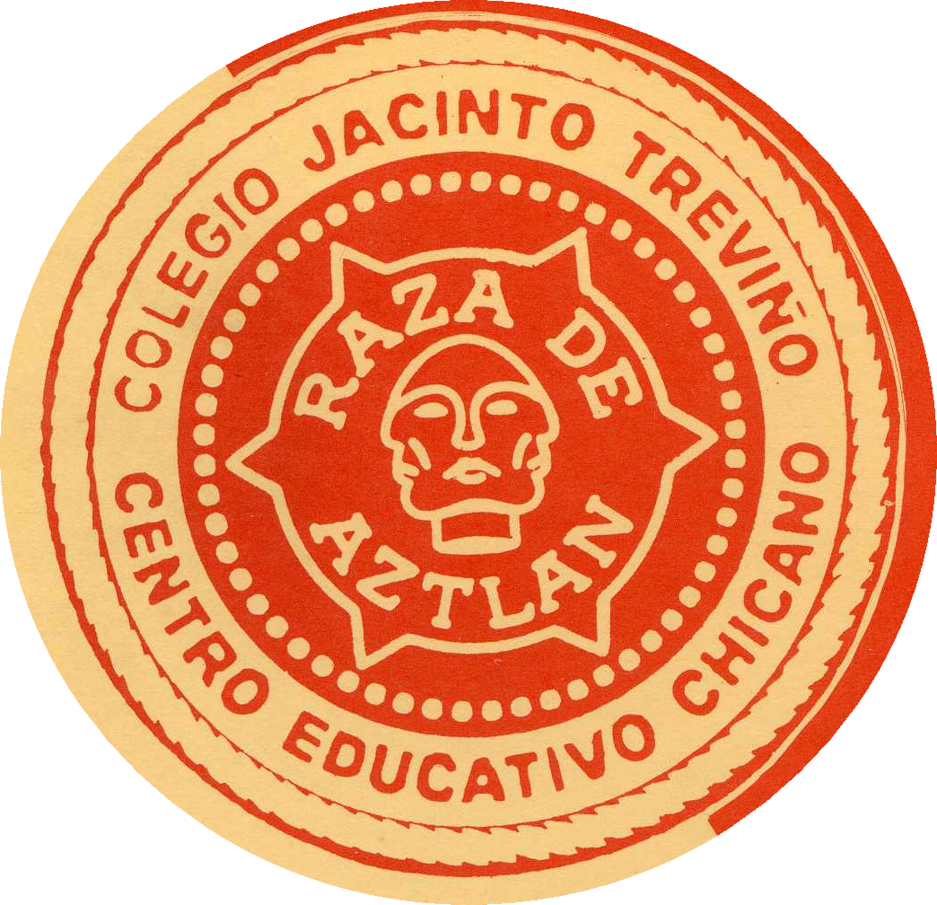

Break: 4:30-5:00PM (Conference Activities Move to McAllen Convention Center)

McAllen Convention Center, Ballroom
Keynote Speaker: 5:30-7:00PM
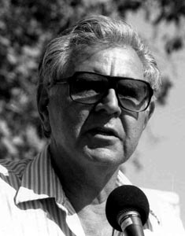
Keynote Address by Dr. Rodolfo Acuña, Professor, California State University at
Northridge, with a special introduction by Dr. Guadalupe San Miguel Jr., University
of Houston

Break: 7:00-7:15PM

Keynote Speaker: 7:15-8:45PM
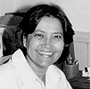
Keynote Address by Ms. Martha P. Cotera, University of Texas at Austin, with a
special introduction by Dr. Norma Cantú, University of Texas-San Antonio

Break: 8:45-9:00PM

Meet Authors and Book Signing: Begins at 9:00PM
Participating authors include: Rodolfo Acuña, Armando C. Alonzo, Dan Arellano, Roberto Calderón, Norma Cantú, Celerino Castillo, Joseph Chance, Martha P. Cotera, Nephtali De. León, Daniel García Ordaz, José Ángel Gutiérrez, Eddie Howell, Josephine Méndez-Negrete, Tatcho Mindiola, Marie “Keta” Miranda, José M. Peña, Emmy Pérez, Marco Portales, Rita Portales, Rosalva Reséndiz, José Reyna, Maggie Rivas-Rodríguez, Charles Robinson III, Elizabeth Rodríguez-Kessler, Guadalupe San Miguel Jr., Joe Sánchez, José Skinner, Rhina Toruño-Haensly, Avelardo Valdez, Clark Von Heller

Noche Cultural: Begins at 9:00PM, (Concurrent with Book signing session)
“¡Viva La Mujer Chicana!”
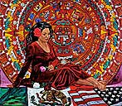

Special Presentation of: “Chicana Her-Story,” María Ramírez, Ohlone College
Special Presentation by: The University of Texas-Pan American Folkloric Dance Company, “Mujeres
de la Revolución Mexicana”
Special Presentation of: “Ángel Negro: Life and Times of Frida Kahlo,” by Mr. Raúl Galván and dance
associates
Special Poetry Reading by: The Gloria Anzaldúa Legacy Project
Saturday March 1, 2007

Registration: Lobby of Building J, 8:00AM-10:00AM
Pan Dulce y Café: Cafeteria, Building H, 8:00AM-9:00AM

Primer Etapa: 9:00-10:15AM

Session 1: Building J 1-208
Building a Road to Sovereignty: Recognizing Chicana/o Rights in the U.S. and the Inequality that Exists in Society and Government under Law (Part One of Two)
Rodolfo Rivera Muñoz, Attorney at Law and Activist, “‘America’ Rules under Guise of Law”
Nephtali De León, Poet and Activist, “A Tribunal to Liberate our Hijacked Sovereignty”

Session 2: Building J 1-214
Indigenous Studies: Culture, Literature, and Pedagogy
Edward Ávila, University of Texas-Pan American, “The Word Aztec from 1950-2002”
Grisel Cano, Houston Community College, “Ancient Manuscripts: Modern Lessons”

Session 3: Building J 1-218
El Arte Como Un Pasaje Espiritual: Buscando Paralelos entre Conceptos Científicos y La Cultura
(Art as a Spiritual Passage: Seeking Parallels in Scientific Concepts and Culture)
Ramón Barela, Harlingen High School
Bobby Estrada, Traditional Healer, Brownsville, Texas

Session 4: Building J 1-702
Discussing Chicana Leadership and Activism:
Lydia González Arizmendi, University of Texas-Pan American, “Dialogical Action in Community Practice:
Lessons from Latina Women Leaders”
José Angel Gutiérrez, University of Texas at Arlington, “Teaching About Activist Chicanas, 1960s-2000:
Comparisons, Contrast, Change, and Contradictions”

Session 5: Building J 1-708
The Co-construction and Negotiation of Identity in an African and Southwestern Borderland
Dora Fitzgerald- University of Incarnate Word, “Constructing Transnational Identities and Culture in
Contemporary Cinema”
Esther Garza-University of Texas at San Antonio, “Students Creating Science Identities through Teachers'
Pedagogical Discourse”
Carmen Guzmán-Martínez, University of Texas at San Antonio, "Bidding" for a Cultural Identity: An
Examination of Negotiation and Contestation in the Third Space”
Malena Salazar-University of Texas at San Antonio, "Electronic Bi-literacy: Latina youth online"

Session 6: Building J 1-216
Workshop: How Can Parents, Educators, and Activists Change “No Child Left Behind” To Make it Work for English Learners?
Peter Farruggio, University of Texas-Pan American

Session 7: Building J 1-606
Focusing on the Revitalization of Indigenous Epistemology as it Applies to K-12 Educational Institutions and Experiences
Norma Ballesteros, University of Arizona
Sean Arce, University of Arizona
Zotero Amavizca, University of Arizona

Session 8: Building J 1-414
Exploring Chicana Feminism and Roles: Chicanas’ Struggle in Literature, Media, and Sitcoms
Petra Guerra, University of Texas-Pan American: “The Mother: Gender Roles and Other Old World Myths in
Alborada, a Spanish Language Telenovela
Daniel Farias, Our Lady of the Lake University: “Searching for Beauty, Searching for Place: The Chicana
Feminist Struggle in Sandra Cisneros’s House on Mango Street and Ugly Betty”

NACCS Tejas Foco Business Meeting: Building J 1-706

Documentary: “Accordion Dreams” Building J 1-704

Break: 10:15-10:30AM

Segunda Etapa: 10:30-11:45AM

Session 1: Building J 1-208
Building a Road to Sovereignty: Recognizing Chicana/o Rights in the U.S. and the Inequality that Exists in Society and Government Under Law (Part Two of Two)
“‘America’ Rules Under Guise of Law”, Rodolfo Rivera Muñoz, Attorney at Law and Community Activist
“A Tribunal to Liberate our Hijacked Sovereignty”, Nephtali De León, Poet and Community Activist

Session 2: Building J 1-212
Deconstructing and Teaching Chicana/o, Latina/o Literature
Javier Rodríguez, Notre Dame University, “Teaching Latina/o Literature through a Transnational Frame to
Non-Latina/o Students”
Lisa Justine Hernández, St. Edwards University, “Beyond Quizzes: Using Blogs to Improve Student
Appreciation of Chicana/o and Latina/o Literature”
Juan José García, University of Texas-Pan American, “Deconstructing Folklore: A CRT/LatCrit Analysis of the
Fairytale Cinderella and the Leyenda La Llorona”

Session 3: Building J 1-216
“When Does a Blind Spot Equal Racism?” (Special Session by Members of the Defend the Honor campaign)
Participants: Maggie-Rivas-Rodríguez, University of Texas at Austin
Trinidad Gonzales, South Texas College

Session 4: Building J 1-218
Indigenous-Centered Pedagogies: Parents and Students Influencing Educational Achievements
Aida Hurtado, University of California, Santa Cruz, (Discussant), “Indigenous Practice as Pedagogy: Social
Identity Altares in the College Classroom”
Karina Cervantez, University of California, Santa Cruz, “Engaging Parents in the College Process: Increasing
College Knowledge Using Telenovelas”
Michael Eccleston, University of California, Santa Cruz, “Expanding the Chicano/Latino Pipeline to University
of California Campuses”

Session 5: Building J 1-708
Teaching High School and College Writing Through the Prism of La Causa
Gina Guzmán, Texas State University: “College Writing Centers and Chicanas/os on the Border”
Blanca Loya, Texas State University: “Alternative Teaching of Writing and Critical Literacy with Reggaeton”
Yazmín Lazcano, Texas State University: “Building Civic Agency by Teaching Chicana/o Students with Multi-
Genre Materials”
Jaime Armín Mejía, Texas State University: “Theoretical and Practical Bridges in Teaching Critical Literacy to
Chicanas/os”

Session 6: Building J 1-710
Chicana/o Conversations and Issues in Higher Education
Beverly M. Pratt, Texas A&M University at College Station, “Racial Minorities in Higher Education”
Jo Ann Reyes Basaldúa, University of Texas at San Antonio, “Chicano Culture and Extended Family: The
Schooling Experience of the Basaldúa Family”

Session 7: Building J 1-606
Remembering Chicana/o Education through Activism
Narciso L. Alemán, Attorney at Law and Activist, “Historical Perspective of the Education of Mexica/Chicano
Children in the Public Educational System of South Texas”
Noe Ramírez, University of Texas-Pan American, “Activism in Educational Settings: Creating Educational
Environments for Promoting awareness of Chicana/o Activism Using Experiential Learning”

Session 8: Building J 1-414
Four Chicano Tales of Getting Through (and Succeeding) in Graduate School and Beyond
John Rodríguez, University of Texas at Arlington
Jesse Esparza, University of Houston
Felipe Hinojosa, University of Houston
Alberto Rodríguez, University of Houston

Session 9: Building J 1-704
Documentary and Discussion:
“Joined at the River: The ‘War on Terror’ in Big Bend, Texas” (For all Opponents of Border Wall)
Lee Basham, South Texas College
Roksana Alavi, South Texas College

Break: 11:45AM-12:00PM

Etapa Final: 12:00-1:15PM

Session 1: Building J 1-208
Perceptions of Hispanic Serving Institution: Different Literacy Practices for Different Institutions
Humberto Cardenas Jr, Laredo Community College
Isabel Araiza, Texas A&M University-Corpus Christi
Susan Loudermilk Garza, Texas A&M University-Corpus Christi

Session 2: Building J 1-212
Education and the Classroom as a Tool to Escape Stereotypes and Discrimination
Manuel Espinoza, University of Colorado at Denver, “Classroom Space as Educational Sanctuary: A Case
Study in the Production of Modal Space”
Roksana Alavi, South Texas College, “Stereotyping and Racial Oppression”
Carlos Siordia, Texas A&M University at College Station, Myths in Educational Metaphors: How the
Education as Contest Metaphor Promotes the Meritocracy Myth”
Session 3: Building J 1-216
Chicana/o Drama: Staging Our Work as Part of a Class
Norma Cantú, University of Texas at San Antonio (Moderator)
Brenda Barroso, University of Texas at San Antonio
Margret Addams, University of Texas at San Antonio
Edward Ortega, University of Texas at San Antonio
Haley Waltman, University of Texas at San Antonio

Session 4: Building J 1-702
Poetry Reading Presenting:
Stephanie Thome, Poet, Texas Tech University
Nephtali De León, Poet and Community Activist

Session 5: Building J 1-606
“Linguicism and Counter-Pedagogies for Teaching Chicana/o Students”
Luz A. Murillo, University of Texas-Pan American
Patrick H. Smith, University of Texas at Brownsville

Session 6: Building J 1-406
Reliving the Chicana/o Education Experience in the Education, The Pacific Northwest and the Lower Rio Grande Valley
Gilberto García, Central Washington University, “Southwest Centric Approach in Chicano Studies Pedagogy: A
Critique from the Pacific Northwest”
Daniel Lara, University of Texas-Pan American, “Not All is the Same: An Alternative Account to the
Traditional Views to Education Among Ethnic Mexicans in the Lower Rio Grande Valley”
Miguel García, South Texas College, “Paying Tribute to Activists in Education: Retelling the Story and
Hardships of Migrant Workers and Farm Workers in Rio Grande Valley Schools”

Break: 1:15-1:30PM

Despedida 1:30-1:45PM, Building D 103
Conducted by Víctor Gómez, South Texas College
and Trinidad Gonzales, South Texas College
